

**Course Report**

**Interface Super App Project Report – Social Media**



**Name：EL Aouad Chaimaa**

**Student ID：202253460009**

**School： School of Artificial Intelligence**

**Major: Artificial Intelligence**

**Interface Super App Project Report**

This report consolidates information from the "Project Plan.pdf", "index.html", "styles.css", and "script.js" files to provide a comprehensive overview of the "Interface - The All-in-One Super App Platform" project.

## 1. Introduction & Project Overview

**Project Title:** Interface Integrated Super App for Communication, Social Networking, E-commerce, Learning, and Freelancing.

**Objective:** To develop a unified platform combining functionalities similar to WeChat (communication), Facebook (social networking), and Amazon (e-commerce), with additional features for learning and freelancing. The project aims to start as a web application and later expand to mobile and desktop apps, reducing "app fatigue" and improving user convenience.

## 2. Core Features (as per Project Plan)

The project plan outlines five core modules and additional features:

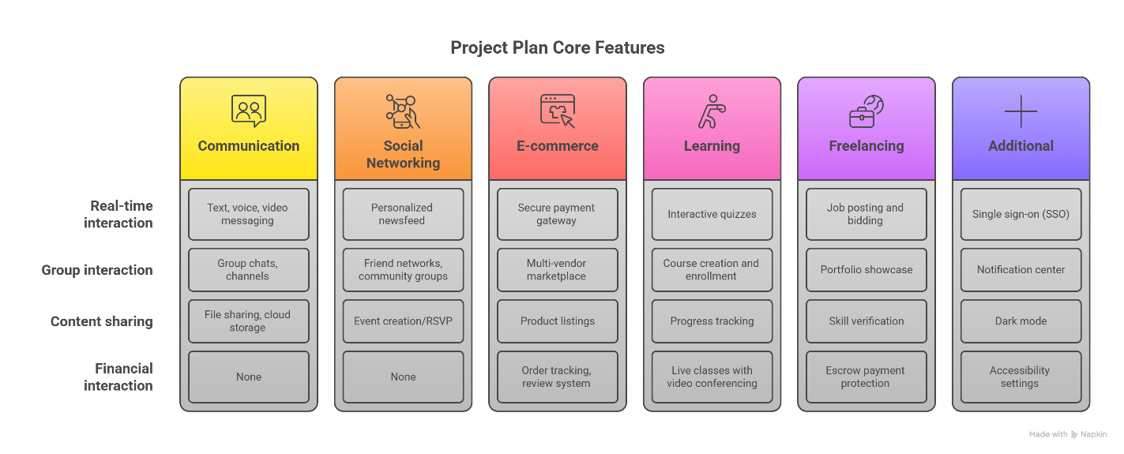

* **Communication Module:** Real-time messaging (text, voice, video), group chats, channels, file sharing, and cloud storage integration.
* **Social Networking Module:** Personalized newsfeed with AI-driven content recommendations, user profiles, friend networks, community groups, and event creation/RSVP.
* **E-commerce Module:** Multi-vendor marketplace, product listings, secure payment gateway (credit cards, digital wallets), order tracking, and review system.
* **Learning Module:** Course creation and enrollment, interactive quizzes, progress tracking, and live classes with video conferencing.
* **Freelancing Module:** Job posting and bidding system, portfolio showcase, skill verification, and escrow payment protection.
* **Additional Features:** Single sign-on (SSO), notification center, dark mode, and accessibility settings.

## 3. Technical Specifications

The technical specifications detail the planned platform, backend, and integrations:

* **Platform:**
  + **Phase 1:** Responsive web application (React.js + Node.js).
  + **Phase 2:** Mobile apps (iOS/Android using Flutter).
  + **Phase 3:** Desktop apps (Electron).
* **Backend:** Microservices architecture, MongoDB (NoSQL) database, and RESTful APIs with JWT authentication.
* **Integrations:** Map API for location-based services, payment gateways (Stripe, PayPal), and cloud storage (AWS S3 or Firebase).

## 4. Design Process

The project follows a structured design process:

1. **Feasibility Study:** Market research and competitor analysis.
2. **Requirements Gathering:** User stories and use-case diagrams.
3. **System Design:** Wireframes, ER diagrams, and architecture planning.
4. **Development:** Agile sprints with iterative testing.

## 5. Testing & Maintenance

A comprehensive approach to quality assurance and ongoing support is planned:

* **Testing:** Unit tests (Jest, Mocha), end-to-end testing (Cypress), and User Acceptance Testing (UAT) with beta testers.
* **Maintenance:** Regular security audits and feature updates based on user feedback.

## 6. Grading Criteria Alignment

The project plan explicitly aligns with several grading criteria:

* **Theoretical Depth:** Covers diverse domains (social media, e-commerce, education) with research-backed solutions.
* **Design Completeness:** Detailed requirement analysis and UML diagrams.
* **Testing & Maintenance:** Comprehensive test plans and scalable maintenance strategies.
* **Summary & Reflection:** Documentation of challenges (e.g., data privacy) and lessons learned.
* **Format Compliance:** Clean codebase with comments and professional documentation.

## 7. Timeline

The project is structured into a phased timeline:

* **Months 1-3:** Web app MVP (communication + social networking).
* **Months 4-6:** E-commerce and learning modules.
* **Months 7-9:** Freelancing module + desktop/mobile app development.
* **Month 10:** Beta launch and user feedback collection.

## 8. Conclusion (Project Plan)

The "Interface" project aims to transform digital interaction by consolidating services, reducing app fatigue, and enhancing user convenience. The phased development ensures manageability and aligns with academic standards for thoroughness and innovation.

# Implementation Status

## HTML (index.html)

The index.html file sets up the basic structure of the web application, incorporating Tailwind CSS for styling and Font Awesome for icons.

* **Structure:**
  + Includes a responsive viewport meta tag.
  + Links to Tailwind CSS CDN, Google Fonts (Inter), and Font Awesome.
  + References local styles.css and script.js files.
  + Features a header with the app title ("Interface"), a notification bell with a dynamic count, a dark mode toggle, and a user profile section.
  + A nav element contains buttons for switching between the five core modules: Chat (Communication), Explore (Social Networking), Shopping (E-commerce), Learning, and Freelancing.
  + A main section houses section elements for each module, with only the "Communication Module" active by default.
  + A footer with copyright information.

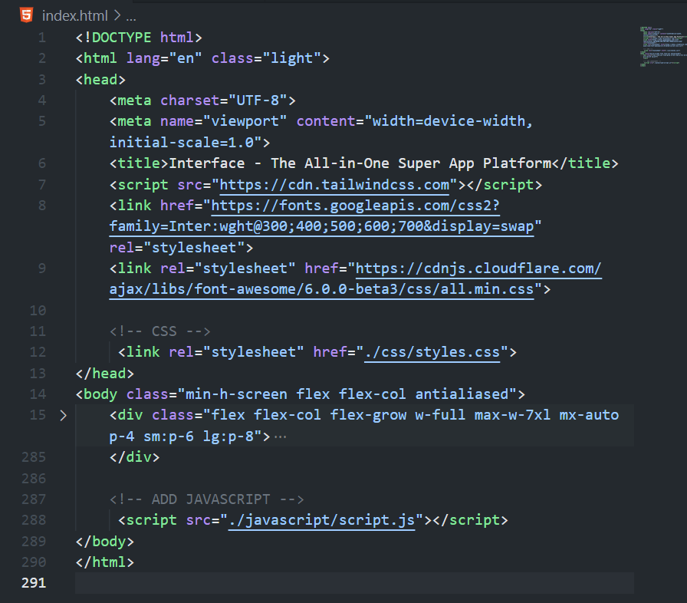

**Module Content**

**Communication Module:** Displays a sample chat conversation with user and "Mehedi" messages, an input field, and a send button.

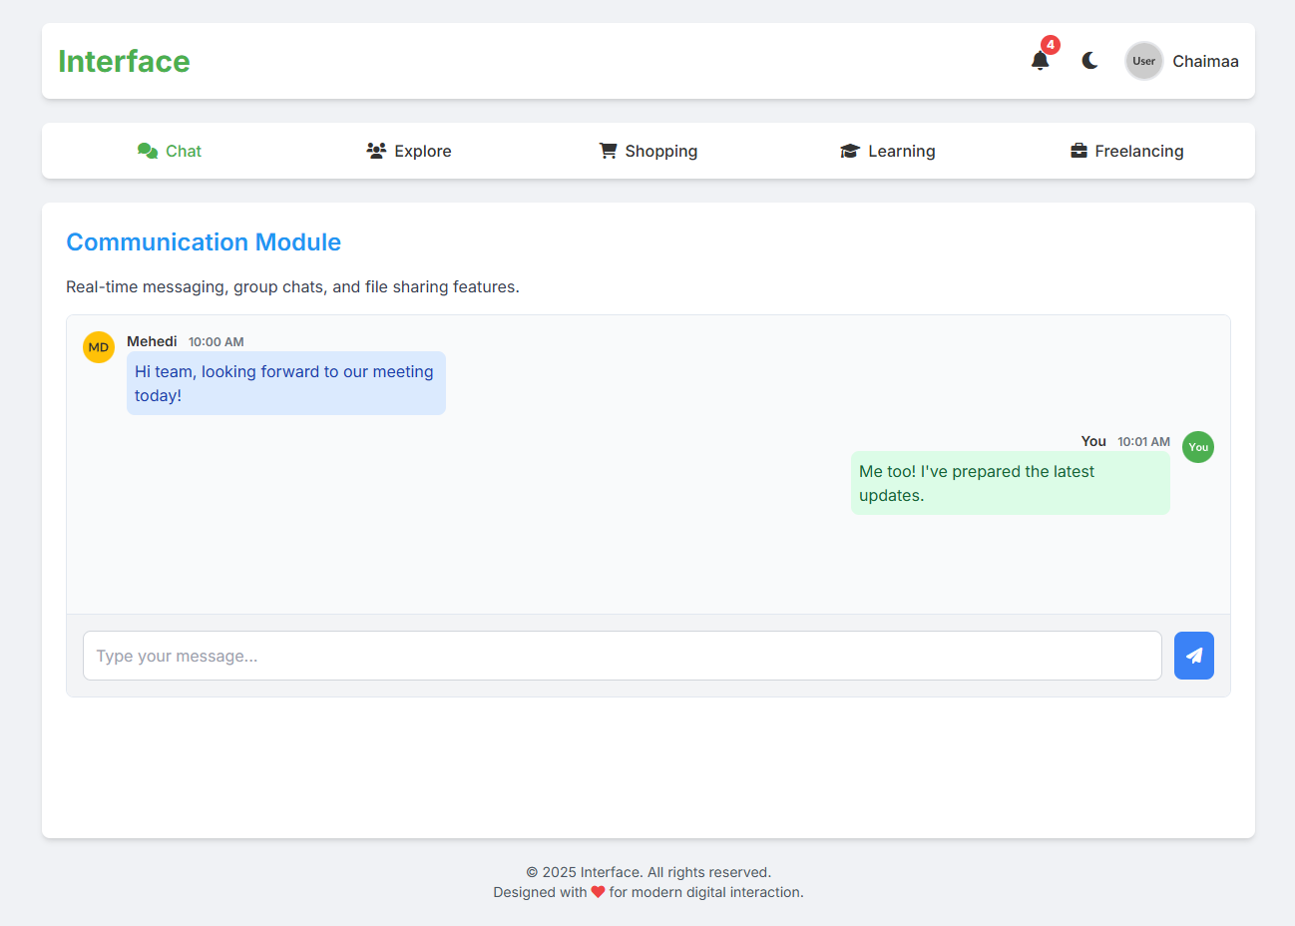

**Social Networking Module:** Shows two sample posts with user avatars, content, image placeholders, and interaction buttons (likes, comments, share).

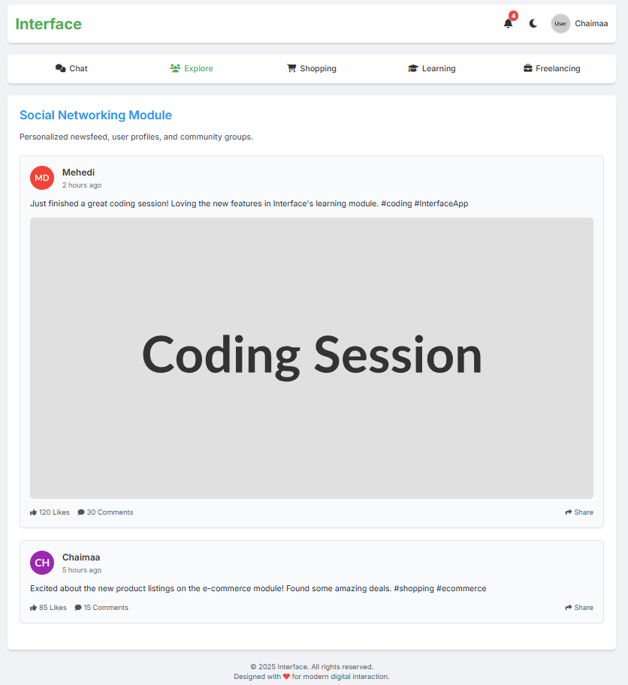

**E-commerce Module:** Presents three product cards with images, titles, descriptions, prices, and "Add to Cart" buttons. Includes a dynamic "Items in Cart" counter.

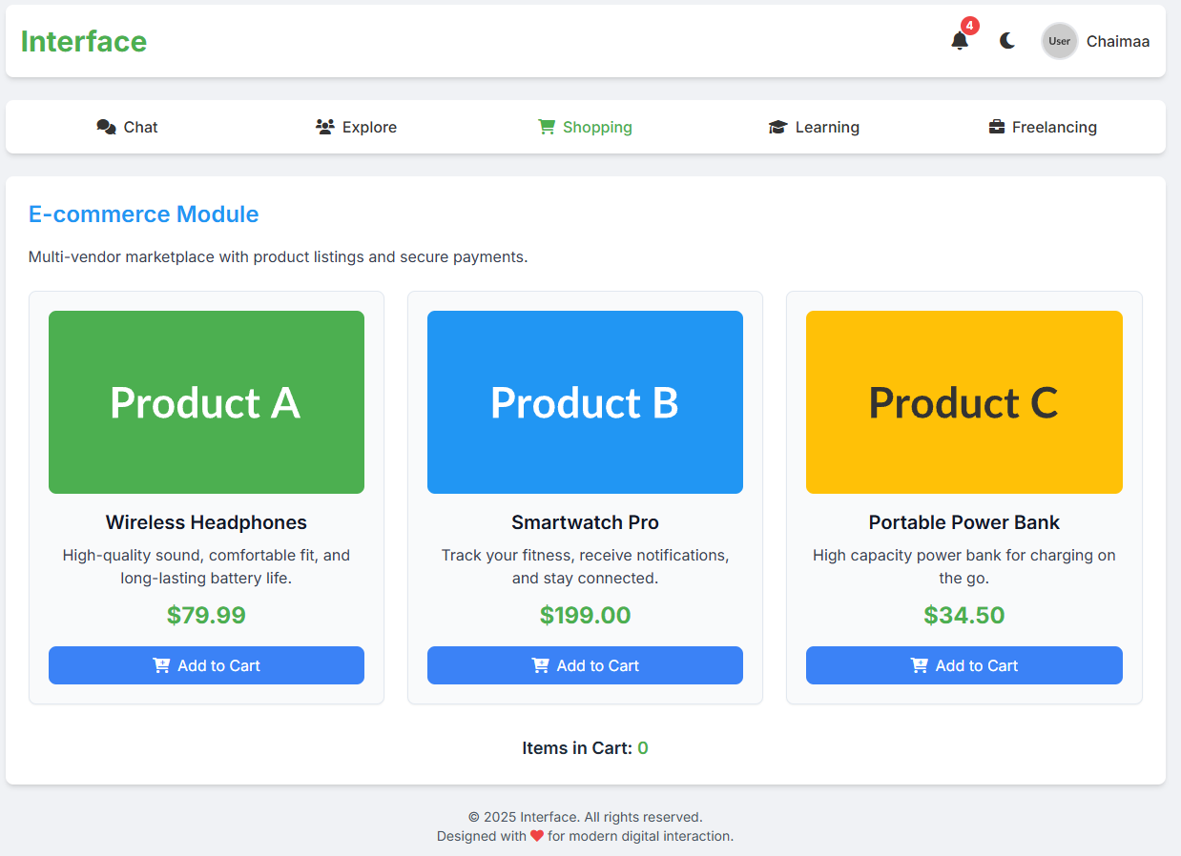

**Learning Module:** Features three course cards with titles, descriptions, duration, reviews, and "Enroll Now" buttons. The courses include "Introduction to Cyber Security" and "Advanced AI & Machine Learning," aligning with the user's stated interest in AI and Cyber Security.

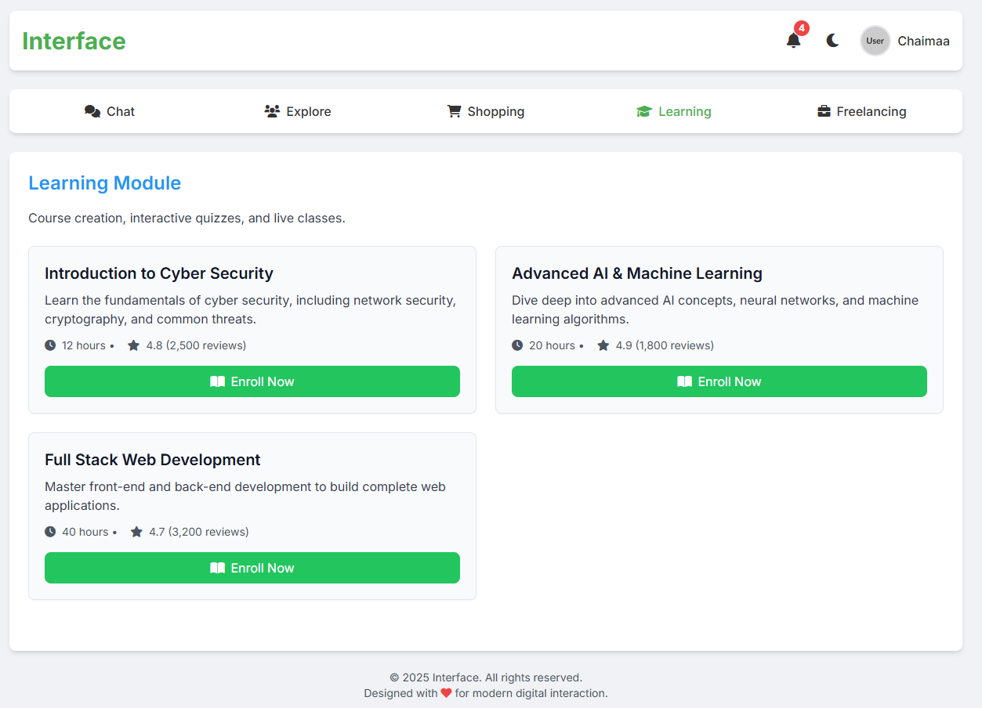

**Freelancing Module:** Displays two job postings with titles, descriptions, budget, location, and posting date.

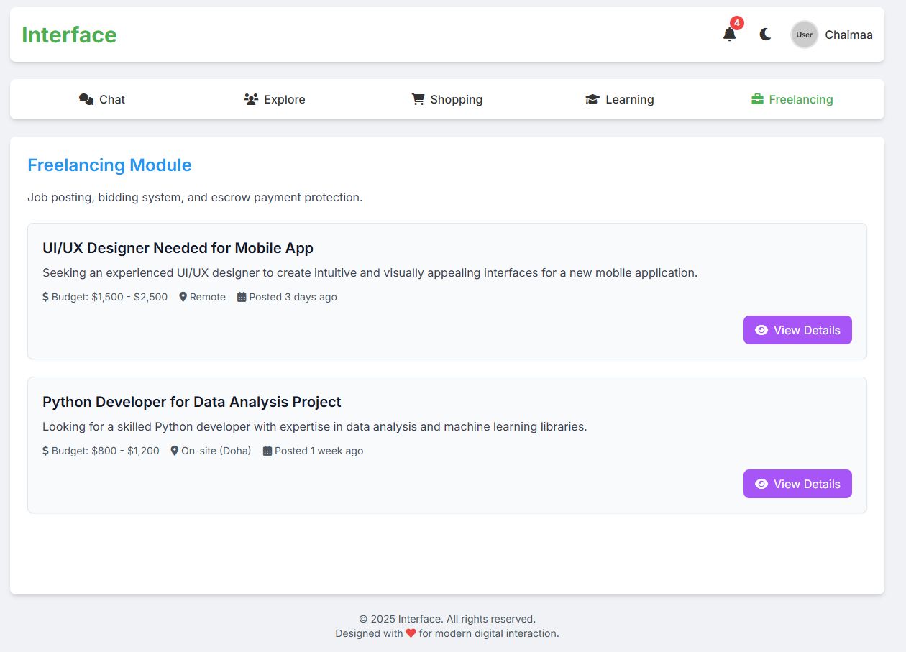

**Responsiveness:** Utilizes Tailwind CSS classes (sm:, md:, lg:) for responsive design, ensuring adaptability across different screen sizes.

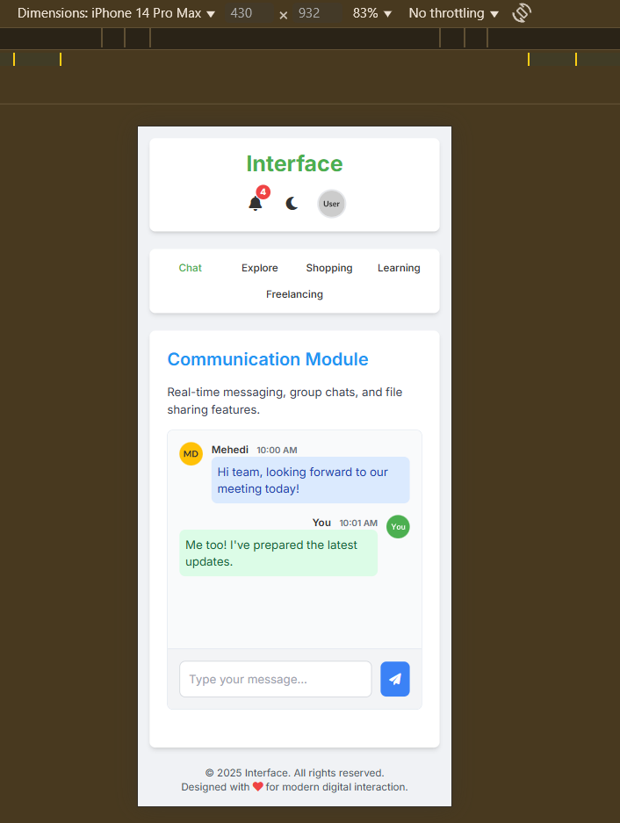

## CSS (styles.css)

The styles.css file defines custom styles to enhance the application's aesthetics and implement dark mode.

* **Typography:** Sets 'Inter' as the primary font.
* **Theme Management:** Defines light and dark body classes to control background, text, card, and border colors, ensuring a smooth transition between modes.
* **Module Visibility:** Uses display: none; for .module-content and display: block; for .module-content.active to manage module visibility via JavaScript.
* **Scrollbar Styling:** Customizes the scrollbar for the chat window.
* **Animations:** Includes a basic slideInRight animation for notification items.

## JavaScript (script.js)

The script.js file handles the interactive functionalities of the web application.

* **DOM Element References:** Initializes constants for various DOM elements, including navigation buttons, module containers, dark mode toggle, chat elements, cart buttons, and notification elements.
* **State Variables:** Manages cartItemCount, notificationCount, and notifications array.
* **Utility Functions:**
  + sanitizeInput(input): A basic client-side function to sanitize user input and prevent XSS attacks.
  + addNotification(message, type): Adds a new notification to the list, prepends it to the notificationList, and updates the count. Supports different notification types (info, success, warning, error).
  + updateNotificationCount(): Updates the displayed notification count and controls the visibility of the notification badge and "No new notifications" message.
* **Event Handlers:**
  + **Navigation:** Event listeners on navButtons to switch active modules and highlight the current active button.
  + **Dark Mode Toggle:** Toggles dark and light classes on the body and stores the preference in localStorage for persistence.
  + **Chat Functionality:**
    - sendMessageBtn click listener: Sanitizes input, creates a new message div (with user avatar and timestamp), appends it to the chat container, clears the input, scrolls to the bottom, and adds a notification about the sent message.
    - chatInput keypress listener: Triggers sendMessageBtn click on 'Enter' key press.
  + **Add to Cart:** Event listeners on addToCartButtons to increment cartItemCount, update the cartCountSpan, and add a success notification.
  + **Notification Bell:** Toggles the hidden class on the notificationDropdown when clicked.
  + **Close Notification Dropdown:** Closes the dropdown when clicking outside the notification bell or dropdown area.
  + **Clear All Notifications:** Clears the notificationList and resets notifications array and notificationCount.
* **Initial Setup:**
  + Applies saved theme preference from localStorage on page load, defaulting to 'light' if no preference is found.
  + Adds several demo notifications on DOMContentLoaded to populate the notification list initially.

## Summary of Implementation

The current implementation effectively demonstrates the core UI and basic interactive functionalities of the "Interface" super app's web MVP. It showcases the communication, social networking, e-commerce, learning, and freelancing modules with placeholder content and client-side interactions. The dark mode toggle and notification system are also functional. The use of Tailwind CSS ensures a responsive and modern design. The inclusion of "Cyber Security" and "AI & Machine Learning" courses in the learning module directly aligns with the user's stated interests.